
good design enables - bad design disables

IDD Members Newsletter, February 2003

CONTENTS

Update on EIDD AGM
Update on Barcelona Project
Barcelona Project Seminar in Tullamore
Irish students win Design for All awards
Design for All : featured project/product
Bookmark this! Featured web-site/on-line resource

Update on EIDD AGM

On Saturday, April 5, 2003, the EIDD AGM will take place at Dublin Castle. The AGM reviews activities during the past year and new national representatives and directors-at-large may be elected. The Board of EIDD attends it and all members of IDD are most welcome as observers.

The AGM will be preceded on April 4 by the international EIDD 10th Anniversary Conference, EQUALITY, DESIGN and the FUTURE. The conference will take place in Dublin Castle, beginning at 9am with a welcome from both Päivi Tahkokallio, President, EIDD and Cearbhall O'Meadhra, President of the IDD. The first session sees speakers address the future of equality and of the information society respectively. The second session examines the future shape of the workplace and consists of a series of presentations, culminating in a discussion. The final session addresses the notion of practical implementation, examining both Irish and international case studies. All IDD members are most welcome to attend what promises to be a stimulating conference.

Update on Barcelona Project
Since the last newsletter in January, five more local authorities have signed up for the Barcelona Declaration, bringing the latest tally up to 59.
At the moment, there is a dual mission being carried out by the Barcelona Project Office – one to create further awareness of the project among local authority groups who have not yet adopted the Declaration while the other information resource address the knotty question – what happens once you sign up for the Barcelona Declaration?
In addition to running regional workshops (see following article on Barcelona Project Seminar in Tullamore ) all local authorities who adopt the Barcelona Declaration are advised to consider the following initial steps;
- To compile a list of all the action taken prior to the adoption of the Declaration.
- To consult with staff, disability advocates and local community groups to ascertain the needs of people living and working in your area
- To set up a web-page that will act as a central resource for your area. In order to do this, local authority groups are advised to look at how this has been managed by Mayo County Council. This page can be viewed at http://www.mayococo.ie/mcc3/Home/BarcelonaDeclaration.asp.
An update on the project can be obtained at http://www.idd.ie/barcelona_introduction.htm, courtesy of Trish Commons.

Barcelona Project Seminar in Tullamore
The training programme seminar took place in Tullamore, Co. Offaly, on the 7th and 8th of January 2003. The programme was attended by 13 managers and local authorities personnel and 4 Disability advocates from Macroom Town Council and Galway City Council, the two selected pilot councils. The seminar addressed issues such as Equality Act and Background, Disability Legislation, Accessibility in its Broadest Sense, Skills of Listening, Barcelona Declaration, Articles, Actions and Projects, Equality/Disability Proofing and Project Guidelines.
The feedback obtained from participants was very positive and complementary.

Irish students win Design for All awards
With the growing necessity of Design for All, it is becoming an educational necessity for all design courses to adopt and promote inclusive principles in design. In order to foster and encourage this trend, this newsletter will profile the work of students who are using Design for All principles in their college work.
Griffith College Dublin student, Catalina Jaramillo, received the Barcelona Project ‘Most Accessible Project ‘ award for her interior architecture project; the conversion of an old church into a spectacular planetarium. Catalina had carefully considered the problems of accessing the created spaces and devoted herself to the articulation of a full and satisfactory design solution.

One of the images from Catalina Jaramillo’s project
David Small, who graduated from GMIT last November with a BSc in construction management developed an interest in "Disability Awareness" and duly completed a thesis on same in the context of the built environment. David received the "Best Student" award in his category and received the "Disability Perpetual Trophy" and travel award which will take him to Spain. The trophy was sculpted by Declan Brassil, manager of GCP, Galway City Partnership who sponsored the award overall. Michael Conneely, Disability Access Officer, GCP said ‘We trust David is the first of many such students who will take an academic interest in disability.’

Design for All : featured project/product
Every issue we will profile a project that intelligently addresses the principles of Design for All, namely equitable use, flexibility in use, simple, intuitive use, perceptible information, tolerance for error, low physical effort and size and space for approach & use
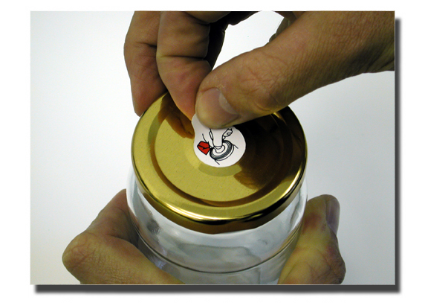
Simple solutions – an easily opened jam jar with vacuum release hole in the lid
In this issue we focus on one of the research projects carried out by Edward Goodwin and Richard Hartshorn as part of the series of case studies commissioned by the Design Council working in collaboration with the Helen Hamyln Research Centre.
In this project, the researchers set out to analyse the openability of supermarket packaging in terms of design for all. This study covered three areas: user-based research, packaging research and strategic design development. A number of research forums were organised to discuss and observe packaging difficulties for both older and disabled users. A large selection of different users were interviewed about their reactions to packaging in terms of difficulties encountered. Participants were asked to complete a two-week log of problems they have with opening packaging. This research, which was carried out in conjunction with Waitrose supermarkets asked if it was possible for a supermarket chain to develop a strategy for more inclusive packaging without the need for special tools or adaptive appliances to aid the opening of packs?
One of the solutions that the researchers came up with is shown above; a jam jar with vacuum release hole in the lid that is activated simply be removing a tab, thus allowing for easier opening.

Bookmark this! Featured web-site/on-line resource
The featured web-site in this issue is the site of the American organization Adaptive Environments Centre (http://www.adaptiveenvironments.org/index.php.) This resource offers information on universal design, technical assistance, consulting, education and training, as well a lists of library and publications resources in the form of print, braille, audio tapes, disks, video-tapes and slides.
Of special interest on this site is the section on universal design projects which showcases outstanding projects which adhere to the principles of Design for All

________________________________________________________________
This newsletter is published by The Institute for Design and Disability
Special thanks to Michal Ozmin, Cearbhall O’Meadhra, Caitriona Shaffrey, Michael Conneely and Paul Fortune for information provided.
All comments on our newsletter are welcome
E-mail info@idd.ie
Phone 6364383
If you have a relevant article you would like to see published, contact Hon. Sec. Caitriona Shaffrey at secretary@idd.ie or IDD PR Officer Tracy Fahey; publicity@idd.ie

