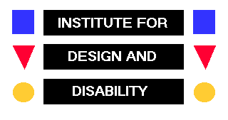
IDD Member Database
Individual Profiles

Surname :
First Name(s) :
Contact Address :
Contact Telephone No. :
Contact Fax :
Contact Email :
Qualifications Academic :

Qualifications Professional :
Present Position Held :
Short Career Profile :

Major Projects, Consultancy, Research and Publications :
Major area(s) of Specialisation:
Prepared to work on contract basis on IDD projects : | yes | no

This information may be used directly or indirectly by IDD in conjunction with project work, which IDD undertakes and is therefore not protected under the Data Protection Act

